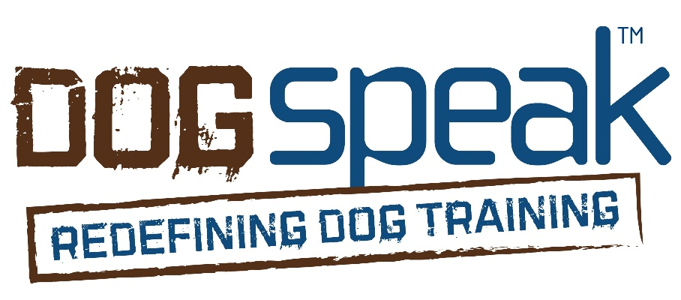
Unleashed and Enriched Program
Release Form
Handler Name: ______________________________________
Phone Number: ______________________________________
Email: ______________________________________________

Owner Information
Owner Name: _________________________________________
Address: ______________________________________________
Phone: _____________________ Email: ____________________

Dog Information
Dog’s Name: __________________________
Breed: _________________________
Age: _________ Sex: ☐ Male ☐ Female Spayed/Neutered: ☐ Yes ☐ No

Services Provided (check all that apply):
☐ On-leash sniffy walks (neighborhood)
☐ Off-leash hikes or walks (Sniff-spot)
☐ Enrichment activities (at home)
☐ Add-on service: _________________________________________________________
☐ Other: __________________________________________________________________

Health and Behavior Disclosure
To the best of my knowledge, my dog:
☐ Is current on all required vaccinations
☐ Is in good health and physically fit for activity
☐ Is not aggressive toward humans or other dogs
☐ Has no history of biting
☐ Has no known behavioral concerns that would put others at risk
If any boxes are unchecked, please explain:

Photo/Video Release
I grant permission to the above handler/organization to take photographs and/or video recordings of my dog for the following purposes:
☐ Social media
☐ Marketing and promotional materials
☐ Website content
☐ Educational or training documentation
☐ Other: _____________________________________________
I understand that no personal identifying information (such as my full name or home address) will be used without my consent.
☐ I give permission
☐ I do not give permission

Liability Waiver & Release
I understand and agree to the following:
- I give permission for the above-named handler/organization to care for, train, and transport my dog without my presence.
- I acknowledge that activities involving dogs carry inherent risks, including but not limited to injury, escape, or illness. I accept full responsibility for any medical costs or liability resulting from my dog’s actions.
- I release the handler/organization and its employees or agents from any liability for injury, loss, or damage to my dog or property arising from services rendered, except in cases of gross negligence or intentional misconduct.
- I authorize the handler to seek emergency veterinary care at their discretion if I cannot be reached, and I agree to be responsible for all related costs.
- I understand that while every effort will be made to ensure my dog’s safety, no environment is risk-free, especially when off-leash or interacting with other animals.

Emergency Contact (other than owner):
Name: _____________________________________
Phone: ____________________________________
Relationship: _______________________________

Consent & Signature
By signing below, I certify that I am the legal owner or authorized guardian of the above-named dog and that I have read and agree to the terms of this release.
Owner Signature: ______________________________________
Date: _______________________
Handler Signature (optional): _____________________________
Date: _______________________

